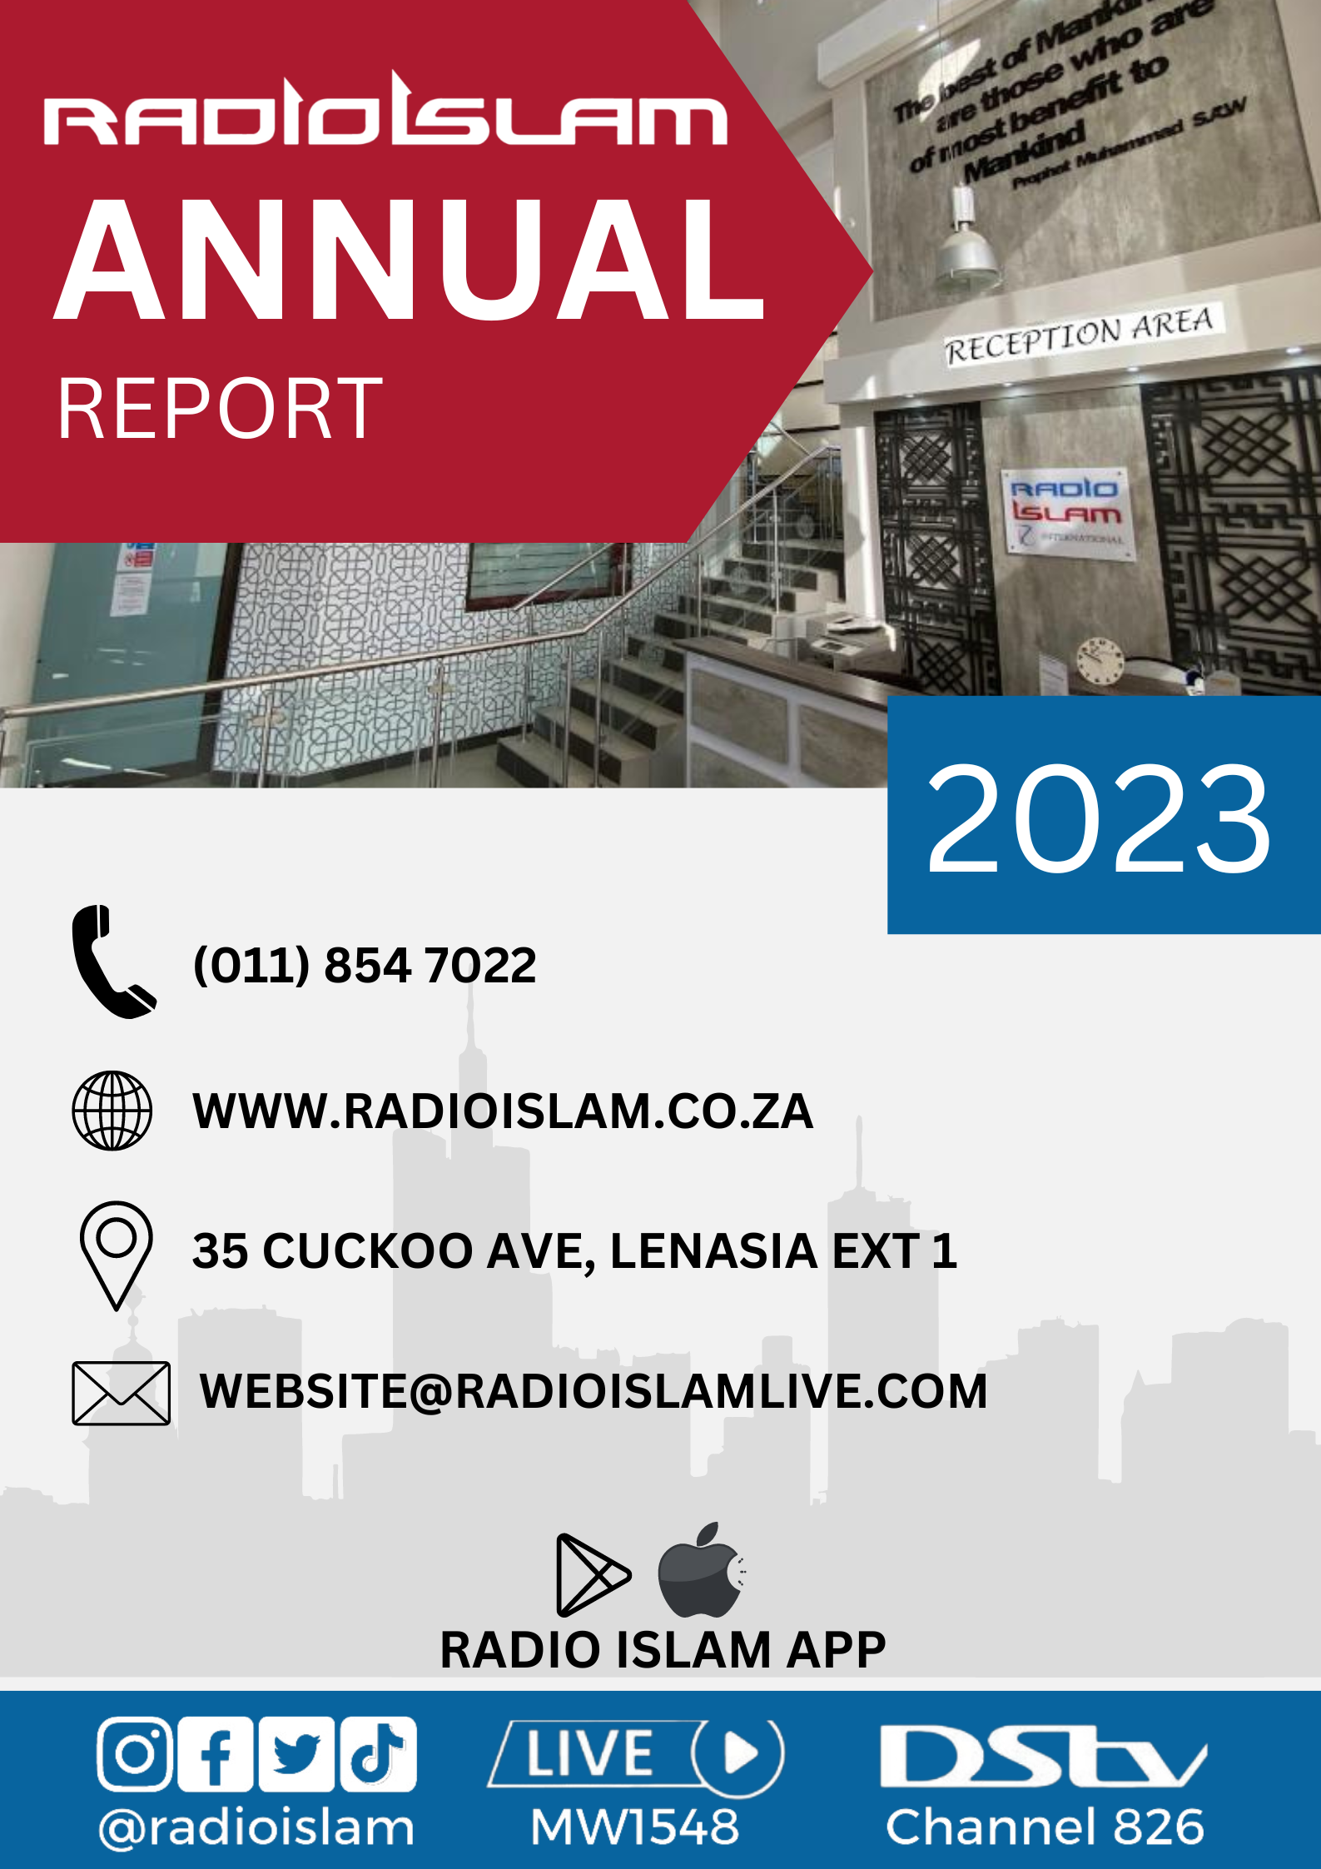

CONTENTS

Introduction | 2
Scope of the Report | 3
Radio Islam Ramadhan Broadcast 1444/2023 | 4 - 5
Radio Islam Hajj Broadcast 1444/2023 | 6 - 8
Radio Islam Outreach Programmes | 9 - 10
News & Current Affairs | 11 - 12
Social Media | 13 - 16
Radio Islam App | 17
Website | 18
General Programming | 19 - 20
Durban Studios | 21
Rescue 786 & Mobile Clinic | 22
Financial Overview | 23
Appreciation | 24

INTRODUCTION

All praise and blessings to Almighty Allah (SWT) The Most Beneficent and Most Merciful. The Bestower of Blessings. We send salutations upon Rasulullah ﷺ Peace and Blessings be upon him.

Radio Islam is a leading media organisation that offers news, views, analysis, and religious guidance on diverse topics of interest to its community.

Our mission is to promote peace, justice, and harmony in the world. And to uphold the values of our religion in the face of challenges and opportunities.

Our coverage in the period under review included:

- The political and social unrest in various countries, such as Myanmar, Ethiopia, Sudan, Afghanistan, Palestine and Yemen, and the humanitarian crises that resulted therefrom.
- The environmental issues that affect the planet including climate change, biodiversity, pollution, and natural disasters. The burning question being what initiatives are needed to address these through sustainable development, conservation, and innovation.
- The cultural diversity that enriches our world. The challenges of intolerance, discrimination and extremism that threaten it.
- The achievements and contributions of Muslims in various fields such as science, technology, arts, and education. The challenges they face about identity, integration and representation.

We hope this annual report will give you an insightful overview of Radio Islams work and impact.

As we understand, the impact of the COVID-19 pandemic was debilitating to all businesses, and Radio Islam, being an NPO, has been no exception.

Despite decreased funding from donors and advertisers who themselves felt the negative economic impacts, Radio Islam has continued with its high-quality broadcast.

Notwithstanding the unprecedented challenges of the past 12 months, Radio Islam has taken significant measures to entrench its position as the ‘’must listen to’’ radio station in many Muslim households.

We are committed to airing high-quality programming that caters for our community's diverse needs and eagerly await serving you in the upcoming years.

We hope it will inspire you to support us in our endeavour to serve the Muslim community and humanity.

We express our sincere gratitude to Allah (SWT) – The Most Merciful and The Bestower of Blessings, and we send peace and blessings upon Rasulullah ﷺ Peace Be Upon Him, the most excellent creation of Allah (SWT).

SCOPE OF THE REPORT

It is our tradition at Radio Islam to present our annual report to our valued listeners and members, detailing our activities and achievements during the Islamic year Muharram 1444 - Dhul Hijjah 1444. The financial report is for the year 1 March 2022 to 28 February 2023.

RAMADHAN BROADCAST 1444/2023

Theme:
"Easy good deeds - Little effort, huge returns"
Our on-air discussions began a few weeks before Ramadhan, focusing on adequately preparing for the blessed month.
Three daily discussions, divided into segments, focusing on virtuous deeds, took place.
Discussions included topics such as:
- What are virtuous deeds?
- Importance of virtuous deeds.
- Rewards of virtuous deeds.
- Many ways of doing virtuous deeds.
- Hastening towards virtuous deeds.
- Examples and explanations of simple virtuous deeds were explained.
Three Talk
- Hosted this year by Ml. Waseem Adam, Hafidh Saad Jada and Ml. Ahmed Wajah.
- Topics focused on social matters and Islamic-related issues. This generated much discussion and feedback.

Ramadhan Drama
- Fietas - The Story of Money revolved around two brothers growing up in the melting pot of Fietas during the 80s and leading lives that will change the course of their history.
- A short synopsis of the drama to refresh the memory: Farouk and Hasan are living a carefree life as teenagers. They get the news that their father has been shot and killed in a political incident. Devastated, their mother withdraws and succumbs to depression. Thus, leaving the two boys to fend for themselves. 17-year-old Farouk leaves school in his Matric year. He is now responsible for supporting his family; buying and selling things to keep them away from the brink of poverty. 16-year-old Hasan continues his schooling. Their mother dies of a broken heart soon after, and the two brothers are left alone.
- The storyline develops years later with both brothers living quite different lives. They have become distant from each other and how circumstances force them to reunite.
Documentary
- Once again, Ml. Ebrahim Moosa produced a stellar documentary enlightening listeners on the History of Muslim Civilisation in India.
Voice to the Homeless
- Ml. Muhammed Kara, pre-recorded interviews with homeless men to understand what caused them to live on the streets. How they passed their days and what plans they had for the future, was aired every Saturday evening.
- The series was well-received and much appreciated by listeners. Many listeners called offering to assist those interviewed.
- This program will be rebroadcast later in the year In Sha Allah.

ALL4One Competition
- From spelling bee to speech contests, Radio Islam has produced groundbreaking campaigns in the past to play its part in shaping tomorrow's leaders. This Ramadhan, the effort continued with the All4One Quiz.
- As Ramadhan fell in the school holidays, we decided to take a different approach when organising the All4One Family Quiz.
- The families, made-up teams and were pitted against each other.
- The response was phenomenal. We had over ten teams taking part. The winners were declared on the night of Eid.
- Questions were centred around:
- Islamiyaat
- General
- Spelling
- Documentary-based
Ladies Programmes.
- Our ladies' programmes were well balanced between spiritual, lifestyle and current affairs. this Ramadhan.
- Muallimah Shaakirah Hunter hosted the Iftar programme between 4:00 pm and 5:30 pm during the week. She covered several topics with a wide range of guests, focusing on social, spiritual and lifestyle discussions.
Live Taraweeh Broadcast
The Taraweeh broadcast this year rotated between three venues:
- Masjid us Salaam in Durban.
- West Street Masjid in Houghton.
- Nurul Islam Masjid in Lenasia.
Tafsir
- Moulana Sulaiman Moola covered the Tafsir of Surah Qasas.
- The Tafsir programme was aired after the Taraweeh Salaah. This was followed by Mufti Menk's Ramadhan series later in the evening.

HAJJ BROADCAST 1444/2023

Theme: "At the heart of Hajj "
The most awaited announcement by Muslims worldwide this season, was the lifting of restrictions imposed three years ago, to curb the spread of the COVID-19 virus. The excitement of Hajj was heightened as soon as the Minister of Hajj and Umrah, Dr Tawfiq Al-Rabiah, announced the overall quota for this year's Haj. Potential Hujjaj were notified of their acceptance to embark on their epic journey. The South African Hajj and Umrah Council also announced that the original quota for South African pilgrims was restored. This added to the already celebratory mood.
For Radio Islam staff, this meant all the plans on the drawing board would now need to come to fruition.
It was decided that the focus for Hajj 1444 would be to look at the soul of Hajj - What does Hajj symbolize? The phrase "At the Heart of Hajj" was adopted to explain to listeners the importance of Hajj as a pillar of Islam.
The theme was broken down into 2 sub-categories.
- The various aspects which the Hajj symbolizes, e.g.
  - Hajj as a Symbol of Love.
  - Hajj as a Symbol of Tauheed.
  - Hajj as a Symbol of Obedience.
  - Hajj as a Symbol of Unity.
  - Hajj as a Symbol of Death.

- The symbolism behind the various rituals, e.g.
  - The Symbolism of Mina.
  - The Symbolism of Ihram.
  - The Symbolism of Arafat.
  - The Symbolism of Jamarat.
- Promos throughout the day ensured the theme was highlighted and prominent.

Qurbani
Qurbani-related discussions were aired the day before Eid.
A special Q&A programme was held before the days of Qurbani.
SANHA (South African National Halal Authority) recorded several videos that were Qurbani related for our social media.

Hajj Desk
- The Hajj Desk is our on-air Hajj portal. This runs throughout the Hajj broadcast half-hourly, providing the listeners with cutting-edge information on the latest Hajj news.
- The news team worked with great enthusiasm to ensure listeners are regularly updated with the latest Hajj-related news, facts, statistics, and feel-good stories.

Hajj Vlog
Moulana Ebrahim Bham contributed several videos of landmarks around Masjid Un Nabawi and Masjid Ul Haram. These were well-received on social media platforms.

Interviews with Hujjaj
- Interviews and crossovers with Hujjaj were conducted at regular intervals throughout the broadcast.
- The Hujjaj were classified into four categories with regular crossovers covering:
  - Ulama.
  - SAHUC daily and weekly reports by members and officials during the days of Hajj
  - First-time Hujjaj.
  - Hujjaj, who had previously completed Hajj.
  - High-profile guests like Zain Bhika, Ismail Vadi etc. who shared their Hajj memories.

Hajj Documentary
- During the Hajj 1444 broadcast, Radio Islam's featured documentary: "Makkah to Madinah - The Hijrah Story", relived the amazing story of a five-person team from the United Kingdom who in January 2023 followed in the blessed footsteps of Rasulullah ﷺ, by walking 547 kilometers. They walked through the desert sands from Makkah to Madinah on the original Hijrah route.
- The production brought to life the spirit of their epic 16-day journey. It concurrently recounted the spirit of the actual Hijrah with all its decisive encounters, lessons, fears and joys.
- Moulana Ebrahim Moosa once again produced the Hajj documentary.

Website
- Banners for all main features were designed and strategically placed on the website's home page.
- Many Hajj-related content was loaded onto the website during the Hajj broadcast.
- News articles, podcasts, opinions and analysis were included.

Hajj Drama
Titled "The Forgotten Haaji", this year's Hajj drama focused on a story occurring at the turn of the century in the early 1900s, before commercial flights became the order of the day. A party of 6 Indian emigrants to SA embarked on their first and only hajj journey. Two brothers, their sister, and their spouses travelled by ship from the port of Durban to Jeddah. The journey was long and arduous. They reach the Saudi port, with the exception of one person from their group, who had contracted the scurvy disease whilst on the ship and passed away. They are awestruck by the Kingdom. They first go to Madinah and then to Makkah. A series of events teach them the true meaning of Hajj.
Social Media
- The social media campaign focused on Hajj-related content for two weeks on all five social media platforms.
- The content was broken up into three categories:
- The Hajj theme/on-air discussions.
- Pictures and videos received from Hajjis.
- Qurbani-related content.
- Social media content reached approximately 750 000 users across 43 countries during the two weeks of Haj.
- Ml. Dawood Sampson conducted video interviews with various Hujjaj, generating much discussion.
- Pictures sent by bloggers were consistently posted on our social media accounts.
- Most of our Hajj crossovers with Hujjaj during the days of Hajj were done via Stream Yard, supplying video content for upload to social media.
- Arafat duas by various scholars were also uploaded onto social media.
5-Day Broadcast
- Our special Hajj broadcast began on Sunday evening, 25th June 2023 This corresponded to the eve of the beginning of Hajj in the Kingdom of Saudi Arabia.
- A variety of presenters presented programs to amplify the spirit of Hajj on the airwaves. This was much appreciated by many of our listeners.
- Live on-air programming began at 5:00 am and ended at 10:00 pm.
Hajj Competition
- The Haj competition brought families together as we looked to unite Haaji “Bhais” and Haaji “Bhens” together in teams to compete against each other for the grand prize.
- The grand prize was a two-night stay at the much sought-after Zaariah Country Estate.

The Sweetest Loss
- Moulana Muhammed Kara interviewed the families of Marhoomeen, who were fortunate to have passed away in the blessed lands of Makkatul Mukarramah or Madinatul Munawwarah.
- These interviews were collated and aired daily for a week, each focusing on a different Marhoom/ah.

Collaboration with other Stations
IFM and Radio Al Ansaar carried our Hajj broadcast from 8-10 am for the duration of the broadcast.

RADIO ISLAM OUTREACH
EVENT | DETAIL
Bosmont - Mufti Ismail Menk | Live Jumuah broadcast
Jessi Duarte  Talk – ML Sulaimaan Ravat  Dua – ML Habib Bobat | National Memorial Service
Laudium – ML Talha Dockrat | Live Jumuah broadcast
Auckland Park Masjid – ML Sulaimaan Ravat  15th Street Fietas Masjid – ML Habib Bobat  23rd Street Fietas Masjid – Mufti Yusuf Moosagie | Jumuah Outreach
Qurtuba Islamic School Workshop – Open to all JHB Schools  Leadership – ML Sulaimaan Ravat  Classroom Dynamics – ML Habib Bobat  Emotional Intelligence – Mufti Yusuf Moosagie | Teacher Development
Nancefield / Bushkoppies  Topic: Discover Yourself  Apa Razina Ndlovu – Muslim Mental Health Advocate  Apa Hasina Ally – Alima & life coach | Ladies Event
Witbank -Aashura Progam  Mufti Zubair Bhayat | Live Broadcast
Syrian Kids – Africa Muslim Agency | Live on Air
Roshnee | Live Jumuah broadcast
Ermelo | Live Jumuah broadcast
Polokwane  Jumuah Outreach  Masjid Al Kauthar -Ml Sulaimaan Ravat  Masjid Al Firdose- ML Sulaimaan Ravat  Jumuah Masjid – Mufti Yusuf Moosagie  Bendor Musallah- Ml Habib Bobat  After Maghrib  Masjid Al Firdose- ML Sulaimaan Ravat  Masjid Al Kauthar – Mufti Yusuf Moosagie  After Esha  Masjid Al Firdose- ML Sulaimaan Ravat | Outreach
Northern Muslim School Workshop  Leadership – ML Sulaimaan Ravat  Classroom Dynamics – ML Habib Bobat  Emotional Intelligence – Mufti Yusuf Moosagie | Teacher Development
Live Jumu'ah Broadcast | Ennerdale
Live Jumu'ah Broadcast | Vanderbijlpark
Swaziland Workshop  Leadership – ML Sulaimaan Ravat  Classroom Dynamics – ML Habib Bobat  Emotional Intelligence – Mufti Yusuf Moosagie | Teacher Development
Swaziland  Mbabane Musjid-Musjid Yusuf  Manzini Musjid-Musjid Huda  Ezulwini Musjid-Islamic Centre | Evening Masjid Program
Swaziland - Jumuah  Manzini Musjid-Musjid Huda – ML Ravat  Ezulwini Musjid-Islamic Centre – ML Habib Bobat | Jumuah Outreach
Madrasah Al-Noor for the blind - Public Speaking Workshop | PMB
Madrasah Tarteelul Quran - Public Speaking Workshop  Mountain Rise Masjid ML Sulaimaan Ravat - Jumuah Outreach  Madrasah Tarteelul Quran – Ml H Bobat  Centre Masjid – Mufti Moosagie | PMB
Radio Bootcamp - Training for public | KZN
Masjid Siratul Jannah – ML Sulaiman Ravat  Mayfair Jumuah – Mufti Yusuf Moosagie | Jumuah Outreach
JHB Radio Bootcamp - Training for public | JHB
Future-proofing Muslim Youth Convention.  Ml. Sulaimaan Ravat | Masjid us Salaam, Durban – Deen Pro
ANC National Conference | NASREC
Nurul Islam | Seerah Jalsa
KZN Musgrave | Seerah Jalsa
Darul Arqam Islamic School and other schools. | Public Speaking workshop
Cape Town City Hall | SONA
Cape Town  Masjid ul Quds ML Habib Bobat  Islamia – ML Sulaimaan Ravat  Shukrul Mubeen – Mufti Moosagie | Jumuah Outreach
Turkey Syria Earthquake – ML Habib Bobat Reporting from the ground. | JUSA relief team
Witbank - ML Sulaimaan Ravat | Meeraj Program
ONLINE – Learning to love for the pleasure of Allah  Apa Shakirah Hunter | Ladies Event
Port Shepstone Islamic School - Teacher Development Workshop | KZN
Phoenix Masjid – ML Habib Bobat  North Beach Mussallah – ML Sulaimaan Ravat  Verulam Masjid – Mufti Moosagie | KZN
How well do you know the Book of Allah – Competition and Qira'ah  Talks - Apa Shakirah Hunter | JHB - Qurtuba

NEWS & CURRENT AFFAIRS
Some major stories covered:
Ahmed Kathrada Foundation "Youth Day Parade" media briefing in Soweto.
Ahmed Kathrada Foundation "Youth Day Parade" at Union buildings, PTA.
Search for a child who fell into a manhole.
Johannesburg Water launches a newly constructed reservoir in Lenasia.
Land grabs – Ext 13, Lenasia.
Gauteng Education opens an online admissions portal in Kensington.
Book launch by AWQAFSA – Indonesia & South African relations – Wendy Wood.
Benoni Councillor on the issue of potholes.
The vandalization of Lenasia High School.
The vandalization of Alpha Primary School.
ANC National Conference at NASREC.
Defend Our Democracy Conference Report meeting in Lenasia.
ANC Rules & Regulations for NEC.
US Secretary of State Visit to SA – University of Pretoria.
Ahmed Kathrada Foundation launches exhibition at Constitutional Hill, Braamfontein.
National Shutdown Pretoria
Electoral Commission Indaba – Braamfontein.
Briefing: Lenasia Train Station Opening - Lenasia
IMA Health Day at TIBA.
Afghanistan to South Africa – Constitutional Hill.
Walk for Freedom – Rose Park.
R554 left incomplete.
Water Issue in Lenasia.
Taxi Rank re-opens in Lenasia.
Flooding in Lenasia.
ANC 5th National elective conference in Nasrec.
Matric results.
Lenasia Ext 13 Post Office Closure.
State of the Nation- address.
State of the Province-address.
Electricity Utility Bills expose.
Shakira Hunter Workshop at Qurtuba

SONA Broadcast Report
Radio Islam International extensively covered the State of the Nation Address (SONA) 2023 in South Africa. The station's presenters and guests discussed diverse topics, including the President's economic plan, social welfare policies, and his stance on national security.
One key issue raised during the coverage was the President's announcement that he would be cutting social grants. This announcement was met with mixed reactions from listeners. Some expressed concern about the impact the cuts would have on the most vulnerable members of society. Others argued that the cuts were necessary to reduce the country's budget deficit.
Another key issue discussed was the President's stance on national security. The President announced that he would be increasing the number of police officers in the country and that he would be taking a tougher stance on crime. This announcement was welcomed by some listeners who felt that the country needed to do more to address the issue of crime. However, others expressed concern that the increased militarization of the police would lead to further erosion of civil liberties.
Overall, Radio Islam's coverage of SONA 2023 provided a comprehensive and nuanced look at the key issues raised during the address. The station's presenters and guests offered a variety of perspectives on these issues. They engaged in thoughtful and respectful debate.
In addition to its live coverage of SONA 2023, Radio Islam also produced several special programs on this topic. These programs included interviews with economic, social welfare, and national security experts. They also featured discussions with ordinary South Africans about their hopes and fears for the country's future.
Radio Islam`s coverage of SONA 2023 was a valuable resource for listeners who wanted to learn more about the key issues facing the people of South Africa. The station's presenters and guests offered a variety of perspectives on these issues, and they engaged in thoughtful and respectful debate, making it an informative and engaging listening experience.

ANC National Conference 2023
Radio Islam provided extensive coverage of the ANC Conference 2023. The station interviewed political analysts, party leaders, and ordinary South Africans about the conference and conducted live broadcasting from the conference venue.
Radio Islam International's coverage focused on the following key issues:
- The ANC presidency battle between incumbent Cyril Ramaphosa and challenger Zweli Mkhize.
- The ongoing corruption scandal engulfing the ANC and the party's efforts to reform itself.
- The ANC's relationship with the Muslim community in South Africa.
Radio Islam's coverage of the ANC Conference 2023 was informative, insightful and provided a valuable platform for South Africans to discuss the future of their country's largest political party.
In addition to its live coverage of the conference, Radio Islam also produced several special programs on the ANC Conference 2023.
These programs featured in-depth analysis of the key issues facing the ANC and provided a forum for South Africans to share their thoughts on the party's future.
Radio Islam's coverage of the ANC Conference 2023 contributed to the public discourse on the future of the ANC and South Africa.

SOCIAL MEDIA
Our daily graphic and video content is produced and uploaded on five of the most popular social media platforms, reaching people in 123 countries worldwide. These platforms are Face book, Twitter, Instagram, Tik Tok and You Tube.

Content

- Weekly videos on various social topics – Ml. Sulaimaan Ravat and Ml. Habib Bobat.
- Guest Ulama videos – Ml. Ebrahim Bham, Ml. Yusuf Ravat, Ml. Akoo, Ml. Ragee.
- Masaail videos - Mufti Yusuf Moosagie.
- Lecture extracts from scholars around the world.
- Daily Duas.
- Motivational Quotes.
- Instagram Competitions - Ramadan and Hajj.
- Instagram Quiz competition.
- Recipes for Stories.
- On-air content adapted to video.

Our Social Media Accounts has been growing steadily—some of the content covered during this period:
- ANC National Conference
- Seerah Jalsa
- SONA 2023
- Al Aqsa Week
- Recipes
- Daily Dua
- The SONA and Turkey Disaster content had huge amounts of hits. Find below some stats:

FACEBOOK AND INSTAGRAM STATS
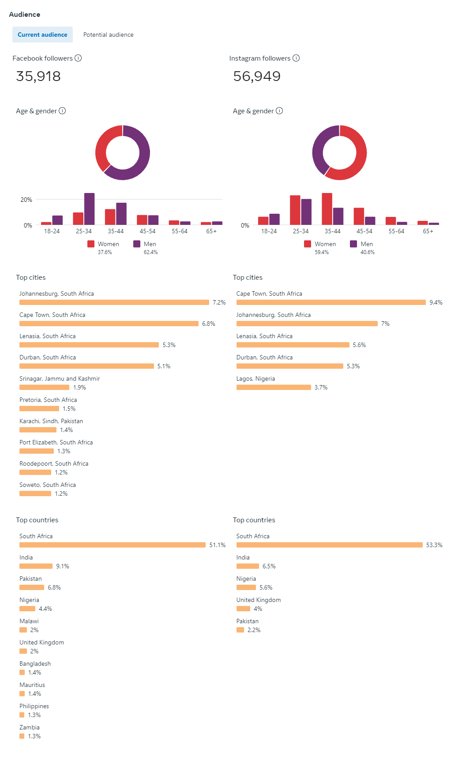

YOUTUBE STATS
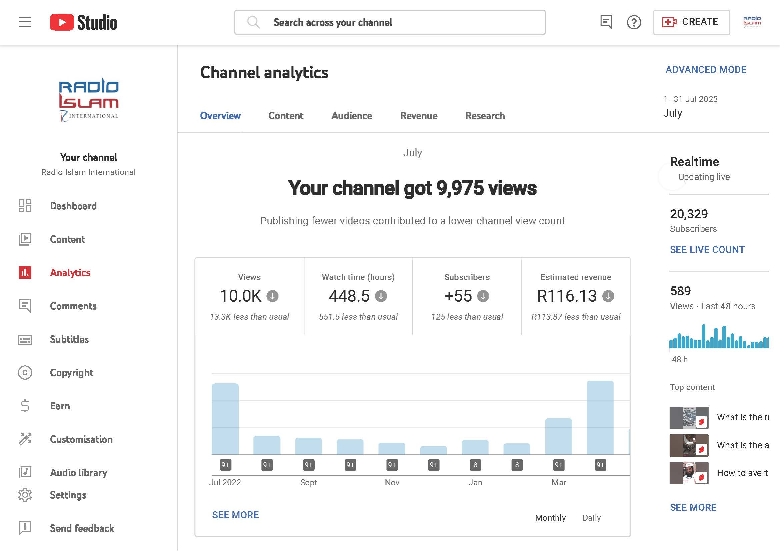

TIK TOK STATS

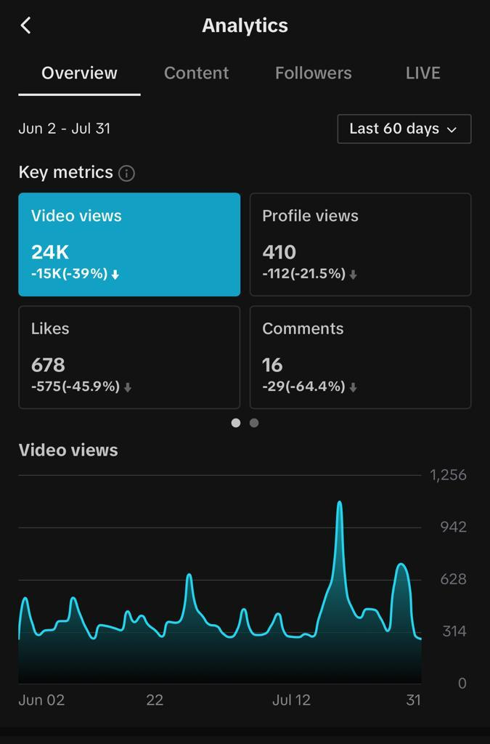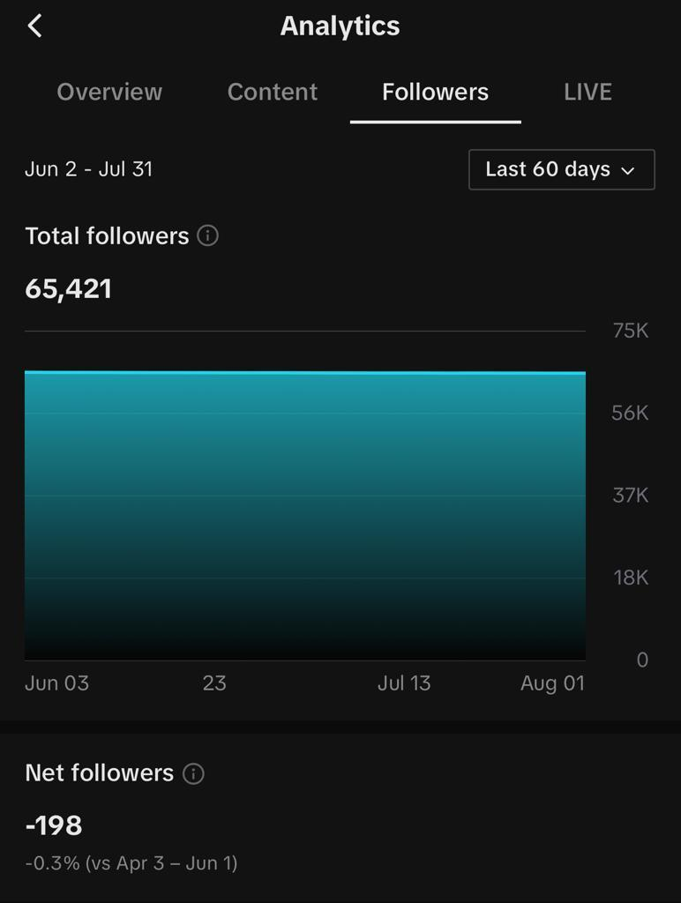

SONA Videos
- Total views 294k for 12 clips.
- Turkey & Syria Earthquake videos - Total views 1.3 million for nine clips.

Ramadhan 2023 in brief
- ML Sulaiman Moola 30 clips on social etiquettes.
- ML Sulaiman Moola Tafsir.
- Easy Good Deeds.
- Motivational clips
- Q & A clips.
- Daily Dua.
- Iftar and Suhoor times.
- The advertising team has been briefed on monetizing the above.

RADIO ISLAM APP

The Radio Islam App, launched in 2021, is available on Android and IOS.
The app lets you listen to Radio Islam clearly and effortlessly via the Internet or Wi-Fi.
It is especially convenient for those on the road, travelling abroad, or residing in an area where MW or satellite signal is unavailable.
It includes features such as:
- News
- Salah Times
- Financials
- Podcasts
- Recipes
The app statistics as of 27 July 2023.

DOWNLOADS
iOS: | 3 300
Android: | 10 800

Android Users in the top 4 countries:
- South Africa (9088)
- United Kingdom (126)
- India (74)
- Zambia (67)
IOS Users in the top 4 countries:
- South Africa (2 426)
- United Kingdom (231)
- United States (227)
- Australia (49)

- Users in 123 different countries

WEBSITE

The Radio Islam team consists of journalists who write stories covering local and world news, sharing valuable information, educating and entertaining our listeners.
The website has had 44 000 new visitors in the last 3 months, increasing its popularity whilst serving as a reference point for the on-air content. The site currently has more than 38 472 pages.
Regular newsletters carry website articles and other relevant information and are sent out via email – newsletter@radioislam.co.za and WhatsApp +27 79 500 0901.

GENERAL PROGRAMMING
On-air themes
DATE | THEME
11 – 15 July 2022 | Difficulties of Ibrahim AS.
18 – 22 July 2022 | Helping Others.
25 – 29 July 2022 | Personal Productivity.
01 – 10 Aug 2022 | Muharram 1443 - Women around the Prophet Musa AS.
11 – 26 Aug 2022 | Women from Ah lul Bayt – Khadijah RA.
29 Aug – 02 Sept 2022 | Safar and Superstitions.
12 – 23 Sept 2022 | Worshipping Allah.
26 Sept – 14 Oct 2022 | The Prophet of Love – Rabiul Awwal 1444 Focus.
17 – 21 Oct 2022 | Eradication of Poverty.
24 Oct – 04 Nov 2022 | Matric Examinations.
07 – 11 Nov 2022 | Burnout Syndrome.
14 – 18 Nov 2022 | Islam and Toilet Etiquette.
21 – 25 Nov 2022 | Children.
28 Nov – 02 Dec 2022 | Disabilities.
05 – 09 Dec 2022 | Exam Results
17 – 20 January 2023 | Planning for the new year.
23 – 27 January 2023 | Importance of Education.
06 – 10 Feb 2023 | Sona 2023.
13 – 17 Feb 2023 | Al Aqsa Week.
20 – 24 Feb 2023 | Social Justice.
27 Feb - 7 Mar 2023 | Sha'baan.
08 - 23 Mar 2023 | Prep for Ramadhan.
24 Mar - Apr 2023 | Ramadhan – Easy Good Deeds.
02 - 05 May 2023 | Press Freedom.
08 - 16 May 2023 | Constructive Criticism.
22 - 26 May 2023 | Over-Thinking.
29 May - 2 Jun 2023 | Nutrition.
5 - 9 Jun 2023 | Cholera.
12 - 15 June 2023 | Virtues of Dhul Hijjah .
19 - 28 June 2023 | Hajj 1444 – At the Heart of Hajj.

PANEL DISCUSSIONS
- We have produced discussions on-air that covered contemporary and youth-focused issues.
- There is diversity in the sound of the panel discussions, with several ladies hosting the panels.
- These were uploaded to the SoundCloud site.
BOOT CAMP
- It was attended by 20 young Muslims from Johannesburg and surrounding areas.
- The participants of the boot camps of both the areas of Durban and Johannesburg learnt the same skills and knowledge. The participants of Johannesburg also had the opportunity to visit Radio Islam’s headquarters in Lenasia and to meet with some of the station's staff.
- The Radio Islam Journalism Boot Camps are a valuable initiative. It provides young Muslims with the skills and knowledge they need to pursue careers in radio journalism. The boot camps also helps to promote diversity and inclusion in the media.

Simulcast with radio Al -Ansaar
Radio Ansaar continues to broadcast Radio Islam’s programming from 8am-10 am weekdays.
There has been positive feedback regarding the broadcasts, especially from the KZN region.

Listeners Association
- Meetings were held on 27 October 2022 and 7 December 2022
Membership
Membership reached 650. Unfortunately, more than 80 percent of members do not attend AGMs nor pay membership fees. The new constitution adopted states;
- Membership fees are R50 annually.
- Any member who does not attend more than 3 AGMs, ceases to remain a member.
- Attendance at AGMs is important.
MW transmitter & technical
- Alhamdulillah our transmitter was upgraded by a professional external company. They replaced the old earth mat with a new earth mat. They commissioned a new transmitter and installed extensive lightning protection.
- We built a new fuel room, transformer room and erected a wall that is 3-meter-high and 450 meters long.
- Total costs; R1,9 million rands.
- This has improved the MW signal significantly.

DURBAN STUDIO

The Durban studio of the Radio is in its seventh year. It has been increasing its footprint within the province by creating a platform for businesses to help and promote advertising and sponsorships.
The station has promoted more than 50 KZN-based businesses, ranging from start-ups to corporates, who have benefited from the increased listenership. The 2 hours of broadcasting on the Radio Al Ansaar airwaves has allowed for further access resulting in an expanding listenership.
Broadcasting continues from the Durban studios. News bulletins are produced, presented and shows being hosted by local presenters. The team provides regular news features via audio, social media and articles for social media and the website.
The Daily Round-Up
This programme is hosted by Ml. Junaid Kharsany and has enjoyed continuous success over the years.
The Insight – previously known as The KZN Brief - is hosted by Annisa Essack on Wednesday nights, covers community news, current affairs in KwaZulu Natal and socio-political current affairs in Africa.
The Big Picture – the eccentric Mr A B Dawjee talks politics, past and present, every Saturday morning. The program is also broadcast simultaneously on Radio Al Ansaar. Mr Mustafa Darsot and attorney Aslam Mayet fill in, in the absence of Mr Dawjee.
The Qiraat Show – Hafidh Hussein Wadi hosts the Saturday morning show with well-known Huffaz and Naat reciters.
The Early Morning Sunday Show – Astrid Badenhorst, a horticulturist, co-hosts the popular Gardening Show with Annisa Essack. The show also covers lifestyle, actuality, health, education, technology, and finance to help empower and uplift the listeners.
The Durban Boot Camp
The Durban boot camp was held from 10-12 February 2023. It was attended by 20 young Muslims from Durban and surrounding areas. Radio Islam Presenter, Ml. Sulaimaan Ravat led the boot camp together with a team of experienced journalists.
The participants learned the basics of radio journalism. They learnt how to write news stories, conduct interviews, and produce radio programs. They also learned about the ethics of journalism and the importance of diversity and inclusion in the media.
The boot camp was a success. Participants gained valuable skills and knowledge and were inspired to pursue careers in radio journalism.
Outcomes
The outcomes of the Radio Islam Journalism Boot Camps were as follows:
- The participants gained valuable skills and knowledge in radio journalism.
- The participants were inspired to pursue careers in radio journalism.
- The boot camps helped to promote diversity and inclusion in the media.
- Bootcamp feedback.
The following were recommended:
- Radio Islam continue to offer these boot camps.
- The Radio Islam Journalism Boot Camps are a valuable initiative that can help to promote diversity and inclusion in the media and should be continued.

RESCUE 786 & MOBILE CLINIC

Rescue 786 Ambulance Service-established 2009

Radio Islam and Jamiatul Ulama South Africa (JUSA) jointly operate an ambulance service; Rescue 786 in the greater Johannesburg region. It offers an intermediate life support service based on "cost recovery, financial sustainability and not for personal gain." It is open to all members of the public without discriminating against anyone based on gender, race, culture, religion or ethnicity.
The number of callouts for a 12-month period and patients attended to by Rescue786 in the greater Johannesburg area are as follows:

- 1603 No. of calls received:
- 1531 No. of patients attended to:
Since inception in 2009, the fleet has grown from 1 to 5 ambulances and one response vehicle.

Mobile Clinic
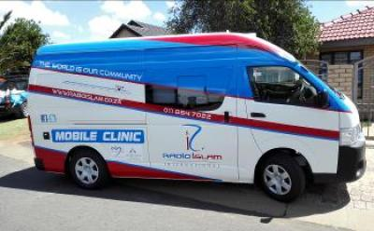
Radio Islam International runs a mobile clinic initiative with the Jamiatul Ulama SA (JUSA) and The Islamic Association of Roshnee.
The clinic is a basic medical clinic staffed by a qualified nurse and provides patients with primary healthcare and access to pro-active diagnosis.
The clinic runs five days a week, servicing the following areas: Lawley Station, Lawley 2, Kapok, Finetown, Eikenhof, Weillers Farm, and Protea South.
In the last year,12223 patients were treated. The cost per patient was R35,93

FINANCIAL OVERVIEW
The difficult times that the economy and country is going through is reflected in these results. The Radio Station made a loss of R1,1 million for the year. Advertising revenue increased from R9,1 to R9,8 million. Donation income dropped to R3,9 million from R4,5 million. Operating expenses increased from R13,2 million to R14, 5 million mainly attributed to the increase usage of diesel due to load shedding and increase in salaries. The company introduced a pension fund for employees during the year. The full Audited Financial Statements are available on Radio Islam’s website (www.radioislam.co.za) under the about us section.

Radio Islam (NON – Profit Company) Registration number 1994/010170/08
Statement of Financial Position as at 28 February 2023
 | 2023  (R) | 2022  (R)
Assets  Non-Current Assets  Property, plant, and equipment | 1 308 634 | 2 123 492
Current Assets  Inventories  Trade and other receivables  Cash and cash equivalents | 782 767  255 835  1 224 591 | 981 970  435 598  1 461 675
 | 2 263 193 | 2 879 243
Total Assets | 3 571 827 | 5 002 735
Equity and Liabilities  Equity  Retained Income | 3 048 655 | 4 141 846
Liabilities  Current Liabilities  Trade and other payables  Provisions | 393 172  130 000 | 738 389  122 500
 | 523 172 | 860 889
Total Equity and Liabilities | 3 571 827 | 5 002 735

Statement of Comprehensive Income the year ended 28 February 2023

 | 2023  (R) | 2022  (R)
Revenue  Cost of sale | 9 857 514  (426 264) | 9 141 220  (368 160)
Gross Profit  Other income  Operating expense | 9 431 250  3 944 676  (14 495 282) | 8 773 060  4 533 534  (13 151 569)
Operating (loss) profit  Investment Revenue | (1 119 356)  26 165 | 155 025  63 916
(Loss) profit for the year  Other comprehensive income | (1 093 191)  - | 218 941  -
Total comprehensive (loss) income for the year | (1 093 191) | 218 941

APPRECIATION
Radio Islam takes this opportunity to express our sincere appreciation to our listeners, donors and well-wishers. Without your support, Radio Islam would not be able to continue its important work of spreading the message of Islam to the world.
We are particularly grateful to our listeners for their continued loyalty and support. Your feedback and suggestions help us to improve our programming and to serve your needs better.
We thank our donors for their generous contributions, allowing us to produce high-quality programming and reach a wider audience.
Finally, we thank our staff members for their dedication and hard work. You are the backbone of Radio Islam, and we could not do this without you.
Jazakallahu khayr again for your support.
Chairman
Abdul Hafiz Mahomed
29 July 2023

Management in Attendance at Board Meetings: Ml Heider A.E Dhorat – Station Manager
Board Members: Br Abdul Hafiz Mahomed – Chairman | Qari Basheer Patel - Deputy Chairman | Br Mohammed Mia – Treasurer | Sister Naseema Karolia - Assistant Treasurer | Sister Zunaida Moosa Wadiwala - Secretary | Attorney Ismail Vally | Attorney Sohail Manga | Attorney Anwar Dawood Suleman | Ml Mahomed Hoosen Ahmed Goolbhai | Ml Umar Sithole | Sister Farhana Dajee | Sister Aamena Seedat | Sister Famidah Moola | Sister Fehmida Adam
